Unit 4
Data Processing with Python: Need of Numpy in data Processing, Powerful properties of numpy , Types of arrays, basic Operations using Numpy, Need of Pandas in data processing.

Introduction to NumPy

NumPy stands for 'Numerical Python' powerful Python library that is widely used for scientific computing, data analysis, and numerical computing tasks.

• pip install NumPy
• In NumPy, an Array is the fundamental object.
• Arrays are used to store homogeneous data elements in a contiguous block of memory.

Array Vs List
Array | List
Arrays are provided by NumPy library. | Lists are built-in data structures in Python.
All elements in an array are of the same data type. | List elements can have different data types.
Arrays use less memory. | Lists use more memory.
Arrays are faster for mathematical operations. | Lists are slower for numerical calculations.
Arrays support vectorized operations. | Lists require loops for many operations.
Arrays are stored in contiguous memory locations. | Lists are not always stored contiguously.
Arrays are mainly used in data science and scientific computing. | Lists are used for general-purpose programming.
Arrays provide better performance with large datasets. | Lists are less efficient for large numerical datasets.
Arrays support multidimensional structures easily. | Lists can also store nested lists but are less efficient.
Example: np.array([1,2,3]) | Example: [1,2,3]

Need of NumPy in Data Processing
1. Fast Computation
NumPy performs calculations much faster than Python lists because it is implemented using optimized C code.

2. Efficient Memory Usage
NumPy arrays consume less memory compared to normal Python lists, making data processing more efficient.

3. Support for Multidimensional Arrays
NumPy supports:
- One-dimensional arrays
- Two-dimensional arrays
- Multidimensional arrays
This helps in handling complex datasets easily.

4. Mathematical and Statistical Functions
NumPy provides built-in functions for:
- Sum
- Mean
- Median
- Standard deviation
- Minimum and maximum values
These functions simplify data analysis.

5. Element-wise Operations
NumPy allows operations on complete arrays without using loops.
Example:
y=x+10y = x + 10y=x+10

6. Data Manipulation
NumPy supports:
- Reshaping arrays
- Sorting data
- Filtering data
- Merging and splitting arrays
These operations are important in data preprocessing.

7. Supports Vectorization
Vectorized operations increase execution speed and reduce code complexity.

8. Integration with Other Libraries
NumPy works with many data science libraries such as:
- Pandas
- Matplotlib
- Scikit-learn

9. Useful in Machine Learning
Machine learning algorithms require matrix and numerical operations, which are efficiently handled by NumPy.

Types of Arrays
An array is a collection of elements of the same type stored in a single variable. It allows you to access each element using an index. Arrays make it easy to store and manage multiple values together.

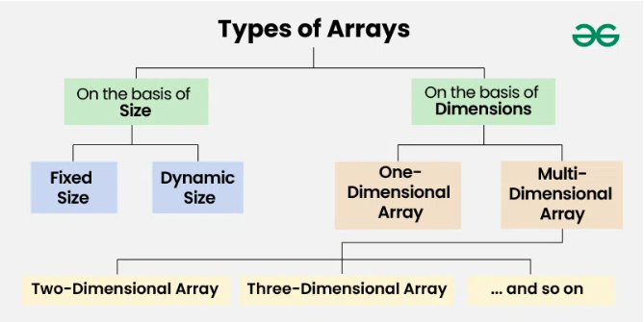
On the basis of Size:
1. Fixed Sized Arrays:
- The size of a fixed-size array cannot be changed after creation.
- Memory is allocated only for the size mentioned in square brackets [].
- Declaring a larger size than needed wastes memory.
- Declaring a smaller size than needed is not enough to store all elements.
- Fixed-size arrays are not preferred when the number of elements is unknown.

# creating a fixed-size list of 5 elements
arr = [0] * 5

# storing values in the list
for i in range(5):
arr[i] = i + 1
# printing list elements
print("Array elements are:", arr)
Output
Array elements are: 1 2 3 4 5

2. Dynamic Sized Arrays:
- The size of a dynamic array can change during program execution.
- Elements can be added or removed as needed.
- Memory is allocated and de-allocated automatically.
- Don’t need to worry about the array size in advance.
- Dynamic arrays are flexible and useful when the number of elements is unknown.

# dynamic array
arr = []

# adding elements
arr.append(10)
arr.append(20)
arr.append(30)

# printing array elements
print("Array elements are:", arr)

# removing last element
arr.pop()

print("After removing last element:", arr)
Output
Array elements are: 10 20 30
After removing last element: 10 20

On the basis of Dimensions
1. One-dimensional Array :
- A 1-D array is a single row of elements stored in a sequence under one name.
- Each element can be accessed using an index starting from 0.
- It is used to store multiple values of the same type in a linear manner.
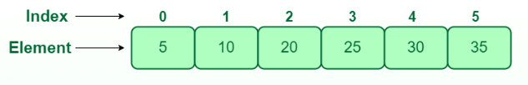

2. Two-dimensional (2D) array:
- A 2-D array is like a table or grid with rows and columns.
- Each element is accessed using two indices: one for the row and one for the column.
- It is used to store multiple values of the same type in a matrix-like structure.
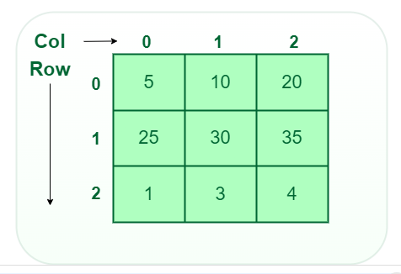

3. Three-dimensional array:
- A 3-D array is like a stack of 2-D arrays, forming rows, columns, and layers.
- Each element is accessed using three indices: for layer, row, and column.
- It is used to store multiple values of the same type in a 3-dimensional structure.
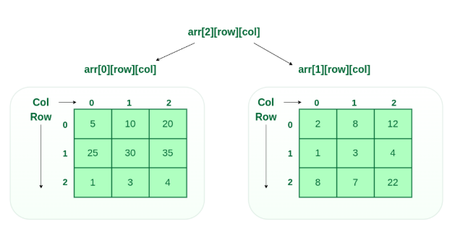

NumPy Arithmetic Array Operations
NumPy provides a wide range of operations that can perform on arrays, including arithmetic operations.
NumPy's arithmetic operations are widely used due to their ability to perform simple and efficient calculations on arrays.
In this tutorial, we will explore some commonly used arithmetic operations in NumPy and learn how to use them to manipulate arrays.

List of Arithmetic Operations
Element-wise Operation | Operator | Function
Addition | + | add()
Subtraction | - | subtract()
Multiplication | * | multiply()
Division | / | divide()
Exponentiation | ** | power()
Modulus | % | mod()
Here's a list of various arithmetic operations along with their associated operators and built-in functions:
To perform each operation, we can either use the associated operator or built-in functions. For example, to perform addition, we can either use the + operator or the add() built-in function.
Next, we will see examples of each of these operations.

NumPy Array Element-Wise Addition
As mentioned earlier, we can use the both + operator and the built-in function add() to perform element-wise addition between two NumPy arrays. For example,
import numpy as np

first_array = np.array([1, 3, 5, 7])
second_array = np.array([2, 4, 6, 8])

# using the + operator
result1 = first_array + second_array
print("Using the + operator:",result1)

# using the add() function
result2 = np.add(first_array, second_array)
print("Using the add() function:",result2)
Run Code
Output
Using the + operator: [ 3 7 11 15]
Using the add() function: [ 3 7 11 15]
In the above example, first we created two arrays named: first_array and second_array.
Then, we used the + operator and the add() function to perform element-wise addition respectively.
As we can see, both + and add() give the same result.

NumPy Array Element-Wise Subtraction
In NumPy, we can either use the - operator or the subtract() function to perform element-wise subtraction between two NumPy arrays. For example,
import numpy as np

first_array = np.array([3, 9, 27, 81])
second_array = np.array([2, 4, 8, 16])

# using the - operator
result1 = first_array - second_array
print("Using the - operator:",result1)

# using the subtract() function
result2 = np.subtract(first_array, second_array)
print("Using the subtract() function:",result2)
Run Code
Output
Using the - operator: [ 1 5 19 65]
Using the subtract() function: [ 1 5 19 65]
Here, we have performed subtraction between first_array and second_array using both the - operator and the subtract() function.

NumPy Array Element-Wise Multiplication
For element-wise multiplication, we can use the * operator or the multiply() function. For example,
import numpy as np

first_array = np.array([1, 3, 5, 7])
second_array = np.array([2, 4, 6, 8])

# using the * operator
result1 = first_array * second_array
print("Using the * operator:",result1)

# using the multiply() function
result2 = np.multiply(first_array, second_array)
print("Using the multiply() function:",result2)
Run Code
Output
Using the * operator: [ 2 12 30 56]
Using the multiply() function: [ 2 12 30 56]
Here, we have used * and multiply() to demonstrate two ways of multiplying the two arrays element-wise.

NumPy Array Element-Wise Division
We can use either the / operator or the divide() function to perform element-wise division between two numpy arrays. For example,
import numpy as np

first_array = np.array([1, 2, 3])
second_array = np.array([4, 5, 6])

# using the / operator
result1 = first_array / second_array
print("Using the / operator:",result1)

# using the divide() function
result2 = np.divide(first_array, second_array)
print("Using the divide() function:",result2)
Run Code
Output
Using the / operator: [0.25 0.4 0.5 ]
Using the divide() function: [0.25 0.4 0.5 ]
Here, we can see both / and divide() give the same result.

NumPy Array Element-Wise Exponentiation
Array exponentiation refers to raising each element of an array to a given power.
In NumPy, we can use either the ** operator or the power() function to perform the element-wise exponentiation operation. For example,
import numpy as np

array1 = np.array([1, 2, 3])

# using the ** operator
result1 = array1 ** 2
print("Using the ** operator:",result1)

# using the power() function
result2 = np.power(array1, 2)
print("Using the power() function:",result2)
Run Code
Output
Using the ** operator: [1 4 9]
Using the power() function: [1 4 9]
In the above example, we have used the ** operator and the power() function to perform exponentiation operation respectively.
Here, ** and power() both raise each element of array1 to the power of 2.

NumPy Array Element-Wise Modulus
We can perform a modulus operation in NumPy arrays using the % operator or the mod() function.
This operation calculates the remainder of element-wise division between two arrays.
Let's see an example.
import numpy as np

first_array = np.array([9, 10, 20])
second_array = np.array([2, 5, 7])

# using the % operator
result1 = first_array % second_array
print("Using the % operator:",result1)

# using the mod() function
result2 = np.mod(first_array, second_array)
print("Using the mod() function:",result2)
Run Code
Output
Using the % operator: [1 0 6]
Using the mod() function: [1 0 6]
Here, we have performed the element-wise modulus operation using both the % operator and the mod() function.

Powerful properties of numpy

1. Fast Computation
NumPy performs calculations much faster than normal Python lists. It uses optimized C programming internally for better performance. Large mathematical operations can be completed quickly using NumPy arrays. It reduces the need for writing loops in programs. This improves execution speed and efficiency in data processing tasks. Therefore, NumPy is widely used in scientific and numerical computing.

2. Multidimensional Arrays
NumPy supports one-dimensional, two-dimensional, and multidimensional arrays. These arrays help in storing and processing large amounts of data efficiently. Multidimensional arrays are useful in machine learning and image processing. Data can be arranged in rows and columns easily. NumPy arrays provide faster access to elements compared to lists. This makes data handling simple and organized.

3. Less Memory Usage
NumPy arrays use less memory than Python lists. All elements in a NumPy array are stored in contiguous memory locations. This reduces memory consumption and improves performance. Large datasets can be managed efficiently using NumPy. Less memory usage also increases processing speed. Therefore, NumPy is suitable for big data applications.

4. Mathematical Operations
NumPy provides many built-in mathematical and statistical functions. Operations like addition, subtraction, multiplication, and division can be performed easily. It also supports functions such as mean, median, standard deviation, and variance. Complex mathematical calculations can be done with fewer lines of code. NumPy is very useful for scientific calculations and data analysis. These operations improve accuracy and reduce manual effort.

5. Broadcasting Feature
Broadcasting allows operations between arrays of different shapes and sizes. It removes the need for manually resizing arrays. Mathematical operations can be performed automatically on arrays. This feature simplifies coding and reduces complexity. Broadcasting also improves program performance and speed. It is one of the most powerful features of NumPy.

6. Array Indexing and Slicing
NumPy provides simple methods for indexing and slicing arrays. Specific elements can be accessed quickly using index values. Slicing helps in extracting a portion of an array easily. Data modification becomes simple with indexing techniques. It reduces programming complexity in data handling tasks. This feature makes NumPy efficient for data manipulation.

7. Support for Linear Algebra
NumPy provides strong support for linear algebra operations. Matrix multiplication, transpose, determinant, and inverse operations can be performed easily. These functions are important in machine learning and scientific research. NumPy simplifies complex matrix calculations. It helps in solving mathematical problems efficiently. Therefore, NumPy is widely used in engineering and data science fields.

8. Integration with Other Libraries
NumPy works efficiently with libraries like Pandas, Matplotlib, and Scikit-learn. These libraries are commonly used in data science and machine learning. NumPy arrays can be easily shared between different libraries. This improves compatibility and performance in projects. It helps developers perform data analysis and visualization effectively. Hence, NumPy forms the foundation of many Python data science tools.

9. Random Number Generation
NumPy provides functions for generating random numbers easily. Random numbers are useful in simulations and machine learning models. Different types of random values can be created using NumPy functions. It supports random integers, floating-point numbers, and arrays. This feature helps in testing and statistical analysis. Random number generation becomes fast and efficient with NumPy.

10. Easy Data Manipulation
NumPy allows easy reshaping, sorting, merging, and splitting of arrays. Large datasets can be managed efficiently using these operations. Data can be modified without affecting performance. It simplifies preprocessing tasks in data science projects. NumPy provides many built-in functions for data handling. Therefore, it is widely used for efficient data manipulation.

